 Introduction to ClaimCenter Configuration

Observation Exercise

1. If you haven't done so already, install a development instance of ClaimCenter to use for the labs in this course.
Configuration Exercise

Configure ClaimCenter to meet the following customer requirement from Acme Insurance.

During the implementation of ClaimCenter, the implementation team for Acme Insurance will be working with imported test data. When viewing any claim, developers want to know if the claim was created by a user or was imported test data. If the claim is from imported test data, then they want to know if it has been modified since the data was imported.

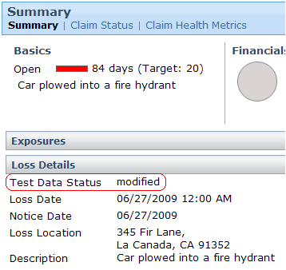

2. Add a single field to the Claim entity named "TestDataStatus_Ext". This field should be able to contain a string up to 15 characters in length.

3. Add a field to the Claim Summary detail view, in the Loss Details. The field should have the following attributes:
- The field appears above the Loss Date field. However, it also appears only if the claim is a test data claim. (See below for additional notes on this.)
- The field maps to TestDataStatus_Ext.
- The field's label is "Test Data Status".
- The field is not editable.

4. Add a rule to the Claim Pre-update rule set which meets the following description:
- The rule is executed only if the claim is a test data claim. (See below for additional notes on this.)
- The rule sets the value of TestDataStatus_Ext to "modified".

5. The ClaimCenter implementation team has provided additional notes:
- Most of the test data has a public ID which starts with the characters "demo_sample". Therefore, to determine if a claim is a test data claim or not, check to see if the public ID starts with "demo_sample". (You can use the startsWith string method, which has the following syntax:
gw.api.util.StringUtil.startsWith( stringToCheck, stringToCheckFor )
- Normally, if a given piece of logic is going to be used in multiple places, it would be better to declare it as a function. However, for the purposes of this lab, you can duplicate the logic to check if a claim is a test data claim in the UI and the business rules.
Test Case

When you have completed your configuration, run the following test case:

6. Navigate to the Ray Newton claim from the sample data. (This test will work for many of the sample data claims, but not all of the sample data claims have publicID’s that begin with “demo_sample”, so use this claim to ensure an accurate test.) Verify that the "Test Data Status" field appears. The field should be blank.
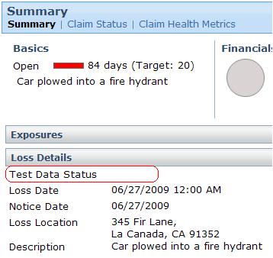

7. Modify the claim and verify that the field changes to "modified".

8. Create a new claim using the quick claim wizard. Once the claim is complete, verify that the "Test Data Status" field does not appear.

